**PRACTICAL – 1**

1. Basic HTML tags and Table structure

|  |  |
| --- | --- |
| **Tags** | **Description • Meaning • Definition** |
| **<a>** | ANCHOR tag creates <a href="http://www.fillster.com">[link](http://www.fillster.com/)</a> to other internet location, or file. |
| **<b>** | BOLD tag is specifying <b>**bold section**</b> within the text document. |
| **<basefont>** | BASEFONT tags defines changes of all text appearance on the web page. |
| **<big>** | BIG tag makes the <big>**text larger**</big> then the rest of the text. |
| **<blockquote>** | BLOCKQUOTE tags  <blockquote>**separate a section**</blockquote>  of text from the surrounding text. |
| **<blink>** | BLINK tags defines text to **<blink>blink</blink>** repeatedly. Internet Explorer doesn't support this tag yet. |
| **<body>** | <html>   <head>   </head>   <body> **Body tags identify the content of a web page.**   </body> </html> |
| **<br>** | Line Break tag is specifying<br> **a new line** |
| **<caption>** | <table>   <caption>**CAPTION tag adds a caption to a table.**</caption>     <tr>       <td>       </td>     </tr> </table> |
| **<center>** | <center>**CENTER tags center text, images, etc.**</center> |
| **<col>** | COL tags are used to define column properties for table columns.  <table>   <colgroup span="2">     <**col width="60" align="left"></col>**     <**col width="80" align="center"></col>**   </colgroup>   <tr>     <td>1st Column</td>     <td>2nd Column</td>   </tr> </table> |
| **<colgroup>** | COLGROUP tags are used to define groups of table columns.  <table>   <**colgroup span="2"**>     <col width="60" align="left"></col>     <col width="80" align="center"></col>   **</colgroup>**   <tr>     <td>1st Column</td>     <td>2nd Column</td>   </tr> </table> |
| **<dd>** | DD tag defines a definition description.  <dl>   <dt>NASA</dt>     <dd>**National Aeronautics and Space Administration**</dd>   <dt>MBA</dt>     <dd>**Master of Business Administration**</dd> </dl> |
| **<del>** | DEL tag indicates <del></del> |
| **<dl>** | DL tag defines a definition list.  **<dl>**   <dt>CSU</dt>     <dd>California State University</dd>   <dt>UN</dt>     <dd>United Nations</dd> **</dl>** |
| **<div>** | DIV tag is a logical section of a web document.  **<div>**   <h1>Home Pets</h1>     <p>Cats</p>     <p>Dogs</p> **</div>** |
| **<dt>** | DT tags defines a definition term.  <dl>   **<dt>HTML</dt>**     <dd>HyperText Markup Language</dd>   **<dt>CSS</dt>**     <dd>Cascading Style Sheets</dd> </dl> |
| **embed>** | EMBED tag gives a command to a browser to include a multimedia elements, such as video, sound files within a web document.  <embed src="videofile.mov" width="100" height="100">  <embed src="musicfile.mid" width="50" height="50">  [Demo • Example](http://www.fillster.com/htmlcodes/embed-tag.html) |
| **<em>** | EM tags <em>emphasize</em> text. |
| **<fieldset>** | FIELDSET tag creates a form for all elements in it.  <fieldset>Find a rounded-corner box around this text.</fieldset> |
| **<font>** | FONT tags attribute text <font face="cursive, serif">font</font>, <font color="#0000ff">color</font>, and <font size="4">size</font>. |
| **<form>** | Form tags define a form.  <form action="contact.html" method="post">   Your Email:     <input type="text" name="visitor-email" maxlength="80" value="" /><br />   Your Name:     <input type="text" name="visitor-name" maxlength="80" value="" /><br />     <input type="submit" value="Send" /> </form>  Top of Form  eMail:   Name:   Bottom of Form |
| **<frame>** | Frame tags define each frame within a frameset.  <html> <head>   <title>Frame Tags in Action</title> </head> <noframes>   <body>     <h1>Sorry, your browser doesn't support this feature!</h1>   </body> </noframes> <frameset cols="35%, 65%">   <frame src ="/htmlcodes/left-frame.html" />   <frame src ="/htmlcodes/right-frame.html" /> </frameset> </html>  [Demo • Example](http://www.fillster.com/htmlcodes/frametags.html) |
| **<frameset>** | FRAMESET tags define a layout of frames.  <html> <frameset cols="45%, *">   <frame src ="/htmlcodes/left-frame.html" />   <frame src ="/htmlcodes/right-frame.html" /> </frameset> </html>  [Demo • Example](http://www.fillster.com/htmlcodes/framesettags.html) |
| **<h1> - <h6>** | H1 - H6 define level 1-6 headers.  <h1>Header 1</h1>  <h2>Header 2</h2>  <h3>Header 3</h3>  <h4>Header 4</h4>  <h5>Header 5</h5>  <h6>Header 6</h6> |
| **<head>** | Head tags define general information about the document, page title, meta-tags, scripts and links to follow, and other commands to browsers.  <html>   <head>     <title>HTML Tags - Head Tag</title>     <meta name="keywords" content="html tags, head tag" />     <link rel="stylesheet" type="text/css" href="style.css" />     <script src="javaexample.js" type="text/javascript"></script>   </head>   <body>   </body> </html> |
| **<hr>** | HR tag draws a horizontal break line.  Two choices for the same result: <hr> or <hr /> |
| **<html>** | HTML tags contain HTML elements, and give a command to browsers to read the document as an HTML document.  <html>   <head>   </head>   <body>   </body> </html> |
| **<iframe>** | iFrame tag creates an inline frame that contains another web page in it. |
| **<img>** | IMG tag attributes an image.  <img src="http://www.fillster.com/images/tutorial.gif" width="60" height="62" alt="Here write a name for your image" />  IMG tag tutorial demonstration |
| **<input>** | INPUT tags define input fields, check boxes, radio buttons.  <form action="contact.html" method="post">   Your Email:     <input type="text" name="visitor-email" maxlength="80" value="" /><br />   Your Name:     <input type="text" name="visitor-name" maxlength="80" value="" /><br />     <input type="radio" name="Level" value="Web Designer" />Web Designer<br />     <input type="radio" name="Level" value="Web Developer" checked="checked" />Web Developer<br />     <input type="checkbox" name="Computer" value="Windows" />Windows<br />     <input type="checkbox" name="Computer" value="Mac" />Mac<br />     <input type="submit" value="Send" /> </form>  Top of Form  eMail:   Name:   Web Designer Web Developer  Windows Mac  Bottom of Form |
| **<i>** | <I> tag is specifying <i>italic text</i>. |
| **<label>** | LABEL tag defines a label to a form control.  <p>Where do you live?</p> <form action="">   <input type="radio" name="country" id="us" />     <label for="usa">USA</label><br />   <input type="radio" name="country" id="uk" />     <label for="uk">UK</label> </form>  Where do you live?  Top of Form  USA UK  Bottom of Form |
| **<legend>** | LEGEND tag assigns a caption in a fieldset element.  <legend>Questionnaire</legend> <p>Where do you live?</p> <form action="">   <input type="radio" name="country" id="usa" />     <label for="usa">USA</label><br />   <input type="radio" name="country" id="canada" />     <label for="canada">Canada</label> </form>  Questionnaire  Where do you live?  Top of Form  USA Canada  Bottom of Form |
| **<li>** | LI tag defines a list of ordered and unordered items.  <ol>     <li>HTML</li>     <li>PHP</li>     <li>JavaScript</li> </ol>  <ul>     <li>HTML</li>     <li>PHP</li>     <li>JavaScript</li> </ul>   1. HTML 2. PHP 3. JavaScript  * HTML * PHP * JavaScript |
| **<marquee>** | MARQUEE tags define different movement behaviors.  [Demos • Examples](http://www.fillster.com/htmlcodes/marquees.html) |
| **<menu>** | MENU tag defines a menu list.  <menu>     <li>Google</li>     <li>Yahoo</li>     <li>MSN</li> </menu>  • Google  • Yahoo  • MSN |
| **<meta>** | META tags are declaring information for the search engine robots and crawlers.  <html>   <head>     <meta name="description" content="Page description goes here.">     <meta name="keywords" content="meta tags, html tags, meta">   </head>   <body>   </body> </html> |
| **<noframe>** | NOFRAME tag is specifying an alternate web page layout for browsers that don't support frames.  <html> <head>   <title>Frame Tags in Action</title> </head> <noframes>   <body>     <h1>Sorry, your browser doesn't support this feature!</h1>   </body> </noframes> <frameset cols="35%, 65%">   <frame src ="/htmlcodes/left-frame.html" />   <frame src ="/htmlcodes/right-frame.html" /> </frameset> </html>  [Demo • Example](http://www.fillster.com/htmlcodes/frametags.html) |
| **<noscript>** | NOSCRIPT tag is specifying a "NOSCRIPT" version page layout for browsers that don't support "SCRIPT" version. NOSCRIP tags are used in conjunction with the JavaScript or VBScript elements.  <script type="text/javascript" language="javascript">   document.write("We are here to learn HTML"); </script> <noscript>   Sorry, your browser doesn't support JavaScript, VBScript. </noscript> |
| **<optgroup>** | OPTGROUP tag creates an option drop-down group menu.  <select>   <optgroup label="Fruits">     <option value ="banana">Banana</option>     <option value ="pineapple">Pineapple</option>   </optgroup>   <optgroup label="Vegetables">     <option value ="tomato">Tomato</option>     <option value ="potato">Potato</option>   </optgroup> </select> |
| **<option>** | OPTION tag creates a drop-down menu. OPTION tag works only in conjunction with a SELECT tag.  <select>     <option value ="beginner" selected="selected">Beginner</option>     <option value ="intermediate">Intermediate</option>     <option value ="advanced">Advanced</option> </select> |
| **<ol>** | OL tags define an ordered list of items.  <ol>     <li>Red</li>     <li>Green</li>     <li>Blue</li> </ol>   1. Red 2. Green 3. Blue |
| **<p>** | <P> tag is specifying a paragraph and creates a new line.  <h4>Header 4</h4>  <p>This is a paragraph.</p> |
| **<pre>** | PRE tag is specifing a preformatted text. This tag does,t let the browsers to eliminate "white spaces" in the text.  <pre>  City London Cool  City Paris Awesome  City New York Great  </pre>  EXAMPLE  City London Cool  City Paris Awesome  City New York Great |
| **<q>** | <Q> tag is specifing short quotations. The function is similar to <blockquote> tag except that <Q> tag doesn't break lines of the text.  <q>I'll be back</q> - is a popular phrase associated with Arnold Schwarzenegger. |
| **<s>** | <S> tag produces a strike throughout a text. <S> tag is depreciated and is not supported in XHTML 1.0 Strict DTD, therefore it's recommended to use DEL tag instead.  Strike through <s>the following text.</s> |
| **<select>** | SELECT tag creates a menu on a form.  <select>     <option value ="planes" selected="selected">Planes</option>     <option value ="trains">Trains</option>     <option value ="automobiles">Automobiles</option> </select> |
| **<small>** | SMALL tag creates a small text.  Compare normal text in relationship to <small>small text</small> |
| **<span>** | SPAN tag is specifying a section of a document.  <div>     <p>Cats and Dogs <span style="color:blue;">are our friends.</span></p> </div> |
| **<strike>** | STRIKE tag creates a strike through words or text. Strike tag is depreciated and is not supported in XHTML 1.0 Strict DTD, therefore it's recommended to use DEL tag instead.  <strike>striking through</strike> |
| **<strong>** | STRONG tag is specifying a strong text.  <div>     <p>Weightlifters are <strong>**strong people.**</strong></p> </div> |
| **<sub>** | SUB tag is defining a subscripted text.  SUB tag is creating <sub>a subscripted text.</sub> |
| **<sup>** | SUP tag is defining a superscripted text.  SUP tag is creating <sup>a superscripted text.</sup> |
| **<table>** | TABLE tag is defining a table.  <table>   <tr>     <td>First Cell</td>     <td>Second Cell</td>   </tr> </table> |
| **<td>** | TD tag creates a data cell.  <table>   <tr>     <td>First Data Cell</td>     <td>Second Data Cell</td>   </tr> </table> |
| **<th>** | TH tag creates a header cell.  <table>   <tr>     <th colspan="2">My Shopping List</th>   </tr>   <tr>     <td>Apples</td>     <td>Pears</td>   </tr> </table> |
| **<tr>** | TR tag creates a row in a table.  <table>   <tr>     <td>Data Cell 1</td>     <td>Data Cell 2</td>   </tr> </table> |
| **<tbody>** | TBODY tag creates a table body.  <table>   <thead>     <tr>       <td colspan="2">>Header - Complete List of Basic HTML Tags</td>     </tr>   </thead>   <tbody>     <tr>       <td>Tags</td>       <td>Attributes</td>     </tr>   </tbody>   <tfoot>     <tr>       <td colspan="2">>Footer - Created by Fillster.com</td>     </tr>   </tfoot> </table> |
| **<textarea>** | TEXTAREA tag creates a text area.  <textarea rows="4" cols="30">   Place you text in here... </textarea> |
| **<title>** | TITLE tag declares a title of an HTML document.  <html>   <head>     <title>Brief description of the web page.</title>   </head>   <body>   </body> </html> |
| **<u>** | U tag makes an underlined text.  This text has the <u>underlined words.</u> |
| **<ul>** | UL tags define an unordered list of items.  <ul>     <li>Code</li>     <li>Script</li>     <li>Tag</li> </ul>   * Code * Script * Tag |

**B:**  create structure of website using colspan and rowspan in table.

<html>

<head>

<title>jewellaryshop</title>

</head>

<body bgcolor="pink">

<table border="1px" cellspacing="0px" cellpadding="0px" height="100px" width="1000px" align="center">

<tr>

<td height="50px" width="250px" align="center"></td>

<td height="50px" width="250px" align="center"></td>

<td height="50px" width="250px" align="center"></td>

<td height="50px" width="250px" align="center"></td>

</tr>

<tr>

<td height="50px" width="1010px" colspan="5" align="center"><h2> This is structure of website..!!</h2></td>

</tr>

</table>

<table border="1px" cellspacing="0px" cellpadding="0px" height="600px" width="1000px" align="center">

<tr>

<td border="1px" cellspacing="0px" height="600px" width="800px"></td>

<td border="1px" cellspacing="0px" height="600px" width="200px">

<table border="1px" cellspacing="0px"cellpdding="0px" height="600px" width="200px">

<tr>

<td height="50px" width="200px" align="center"></td>

</tr>

<tr>

<td height="50px" width="200px" align="center"></td>

</tr>

<tr>

<td height="50px" width="200px" align="center"></td>

</tr>

<tr>

<td height="50px" width="200px" align="center"></td>

</tr>

<tr>

<td height="50px" width="200px" align="center"></td>

</tr>

<tr>

<td height="350px" width="200px" align="center"></td>

</tr>

</table>

</td>

</tr>

</table>

</body>

</html>

**Output:-**

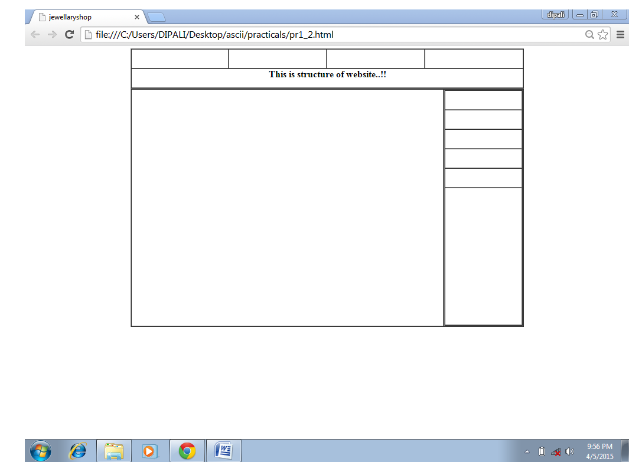

**C:** 5 pages website with content using table.

**Page:-2(home page)**

**HTML:**

<html>

<head>

<title>jewellaryshop</title>

</head>

<body bgcolor="#FFCC99">

<table border="1px" cellspacing="0px" cellpadding="0px" height="100px" width="1020px">

<tr>

<td height="50px" width="252px" align="center"><font color="#999999 size="+1"><a href="home.html"><h2>Home</h2></a></font></td>

<td height="50px" width="252px" align="center"><font color="BLUE" size="+1"><a href="man.html"><h2>Man</h2></a></font></td>

<td height="50px" width="253px" align="center"><font color="BLUE" size="+1"><a href="woman.html"><h2>Woman</h2></a></font></td>

<td height="50px" width="253px" align="center"><font color="BLUE" size="+1"><a href="contactus.html"><h2>Contact us</h2></a></font></td>

</tr>

<tr>

<td height="50px" width="1010px" colspan="5" align="center"><font color="#CC6666 size="+44"><h1>Jwellary Shop</h1></td>

</tr>

</table>

<table border="1px" cellspacing="0px" cellpadding="0px" height="600px" width="1000px">

<tr>

<td border="1px" cellspacing="0px" height="600px" width="800px"><img src="../img/17-4273.jpg" width="800px" height="600px" alt="img"></td>

<td border="1px" cellspacing="0px" height="600px" width="200px">

<table border="1px" cellspacing="0px" cellpdding="0px" height="600px" width="200px">

<tr>

<td height="50px" width="200px" align="center"><H3>Special Categories</H3></td>

</tr>

<tr>

<td height="50px" width="200px" align="center"><a href="diamondring.html"/><h3/>Diamond Rings</a></td>

</tr>

<tr>

<td height="50px" width="200px" align="center"><a href="diamondbrecelet.html"/><h3/>Diamond Brecelet</a></td>

</tr>

<tr>

<td height="50px" width="200px" align="center"><a href="diamondnecklace.html"/><h3/>Diamond Necklace</a></td>

</tr>

<tr>

<td height="50px" width="200px" align="center"><a href="diamondearring.html"/><h3/>Diamond Earring</a></td>

</tr>

<tr>

<td height="350px" width="200px" align="center"><img src="../images/DBroochs(2).jpeg" width="200" height="350" alt="img"/></td>

</tr>

</table>

</td>

</tr>

</table>

</body>

</html>

**Page:-2(man page)**

**HTML:**

<html>

<head>

<title>Man</title>

</head>

<body bgcolor="#66CCFF">

<table border="1px" cellspacing="0px" height="50px" width="1040px" align="center">

<tr>

<td height="50px" width="255px" align="center"><font color="BLUE" size="+1"><a href="home.html"><h2>Home</h2></a></font></td>

<td height="50px" width="255px" align="center"><font color="BLUE" size="+1"><a href="man.html"><h2>Man</h2></a></font></td>

<td height="50px" width="255px" align="center"><font color="BLUE" size="+1"><a href="woman.html"><h2>Woman</h2></a></font></td>

<td height="50px" width="255px" align="center"><font color="BLUE" size="+1"><a href="contactus.html"><h2>Contact us</h2></a></font></td>

</tr>

</table>

<table border="1px" cellspacing="0px" cellpadding="0px" height="50px" width="1040px"align="center">

<tr>

<td height="50px" width="323px" align="center"><font color="RED" size="+1"><h4><a href="mchain.html">CHAIN</a></h4></td>

<td height="50px" width="323px" align="center"><font color="RED" size="+1"><h4><a href="mbrecelet.html">BRECELETS</a></h4></td>

<td height="50px" width="374px" align="center"><font color="RED" size="+1"><h4><a href="mring.html">RINGS</a></h4></td>

</tr>

</table>

<table border="1px" cellspacing="0px" cellpadding="0px" height=600px" width="1000px"align="center">

<tr>

<td border="1px" cellspacing="0px" cellpadding="0px" height="600px" width="800px">

<table border="1px" cellspacing="0px" cellpadding="0px" height="600px" width="800px">

<tr>

<td height="200px" width="200px"><imgsrc="../images/CGWatch.(1).jpg" width="200px" height="200px" alt="img"/></td>

<td height="200px" width="200px" align="center"><img src="../images/CDWatch.(1).jpg" width="200px" height="200px" alt="img"/></td>

<td height="200px" width="200px" align="center"><img src="../images/GWatch.(1).jpg" width="200px" height="200px" alt="img"/></td>

<td height="200px" width="200px"align="center"><img src="../images/CSWatch.(1).jpg" width="200px" height="200px" alt="img"/></td>

</tr>

<tr>

<td border="1px" height="50px" width="200px"

align="center"><h3>10000rp</h3></td>

<td border="1px" height="50px" width="200px"

align="center"><h3>13000rp</h3></td>

<td border="1px" height="50px" width="200px"

align="center"><h3>15000rp</h3></td>

<td border="1px" height="50px" width="200px" align="center"><h3>12000rp</h3></td>

</tr>

<tr>

<td height="100px" width="800px" colspan="5"></td>

</tr>

<tr>

<td height="200px" width="200px"><img src="../images/DWatch.(2).jpg" width="200px" height="200px" alt="img"/></td>

<td height="200px" width="200px"><img src="../images/GWatch.(5).jpg" width="200px" height="200px" alt="img"/></td>

<td height="200px" width="200px"><img src="../images/DWatch.(4).jpg" width="200px" height="200px" alt="img"/></td>

<td height="200px" width="200px"><img src="../images/GWatchs(2).jpg" width="200px" height="200px" alt="img"/></td>

</tr>

<tr>

<td border="1px" height="50px" width="200px" align="center"><h3>9000rp</h3></td>

<td border="1px" height="50px" width="200px" align="center"><h3>12000rp</h3></td>

<td border="1px" height="50px" width="200px" align="center"><h3>10000rp</h3></td>

<td border="1px" height="50px" width="200px"align="center"><h3>16000rp</h3></td>

</tr>

</table>

</td>

<td border="1px" cellspacing="0px" height="600px" width="200px">

<table border="1px" cellspacing="0px" height="600px" width="200px"align="center">

<tr>

<td height="50px" width="200px" align="center"><H4>Special Categories</H4></td>

</tr>

<tr>

<td height="50px" width="200px"

align="center"><a href="diamondring.html"/><h3/>Diamond Rings</td>

</tr>

<tr>

<td height="50px" width="200px" align="center"><a href="diamondbrecelet.html"/><h3/>Diamond Brecelet</td>

</tr>

<tr>

<td height="50px" width="200px" align="center"><a href="diamondnecklace.html"/><h3/>Diamond Necklace</td>

</tr>

<tr>

<td height="50px" width="200px" align="center"><a href="diamondearring.html"/><h3/>Diamond Earring</td>

</tr>

<tr>

<td height="350px" width="200px" align="center"><img src="../images/ab3.jpeg" width="200" height="350" alt="img"/></td>

</tr>

</table>

</td>

</tr>

</table>

</body>

</html>

**Page:-3(woman page)**

<html>

<head>

<title>Woman</title>

</head>

<body bgcolor="pink">

<table border="1px" cellspacing="0px" height="50px" width="1030px" align="center">

<tr>

<td height="50px" width="250px" align="center"><font color="BLUE" size="+1"><a href="home.html"><h2>Home</h2></a></font></td>

<td height="50px" width="250px" align="center"><font color="BLUE" size="+1"><a href="man.html"><h2>Man</h2></a></font></td>

<td height="50px" width="250px" align="center"><font color="BLUE" size="+1"><a href="woman.html"><h2>Woman</h2></a></font></td>

<td height="50px" width="250px" align="center"><font color="BLUE" size="+1"><a href="contactus.html"><h2>Contact us</h2></a></font></td>

</tr>

</table>

<table border="1px" cellspacing="0px" height="50px" width="1030px" align="center">

<tr>

<td height="50px" width="200px" align="center"><font color="RED" size="+1"><h4><a href="wring.html">RINGS</a></h4></td>

<td height="50px" width="200px" align="center"><font color="RED" size="+1"><h4><a href="wnecklace.html">NECKLACE</a></h4></td>

<td height="50px" width="200px" align="center"><font color="RED" size="+1"><h4><a href="wbrecelet.html">BRECELET</a></h4></td>

<td height="50px" width="200px" align="center"><font color="RED" size="+1"><h4><a href="wbangle.html">BANGLES</a></h4></td>

<td height="50px" width="200px" align="center"><font color="RED" size="+1"><h4><a href="wearing.html">EARRING</a></h4></td>

</tr>

</table>

<table border="1px" cellspacing="0px" height=600px" width="1000px" align="center">

<tr>

<td border="1px" cellspacing="0px" height="600px" width="800px">

<table border="1px" cellspacing="0px" height="600px" width="800px">

<tr>

<td height="200px" width="200px" align="center"><img src="../images/CGManglesutra.(1).jpg" width="200px" height="200px" alt="img"/></td>

<td height="200px" width="200px" align="center"><img src="../images/CDManglesutra.(1).jpg" width="200px" height="200px" alt="img"/></td>

<td height="200px" width="200px" align="center"><img src="../images/DManglesutra.(3).jpg" width="200px" height="200px" alt="img"/></td>

<td height="200px" width="200px" align="center"><img src="../images/DChains(2).jpg" width="200px" height="200px" alt="img"/></td>

</tr>

<tr>

<td height="50px" width="200px" align="center"><h3>200000rp</h3></td>

<td height="50px" width="200px" align="center"><h3>400000rp</h3></td>

<td height="50px" width="200px" align="center"><h3>608000rp</h3></td>

<td height="50px" width="200px" align="center"><h3>100000rp</h3></td>

</tr>

<tr>

<td height="100px" width="800px" colspan="5"></td>

</tr>

<tr>

<td height="200px" width="200px"><img src="../images/CSManglesutra.(1).jpg" width="200px" height="200px" alt="img"></td>

<td height="200px" width="200px"><img src="../images/DManglesutra.(5).jpg" width="200px" height="200px" alt="img"></td>

<td height="200px" width="200px"><img src="../images/DManglesutra.(2).jpg" width="200px" height="200px" alt="img"></td>

<td height="200px" width="200px"><img src="../images/GManglesutra.(3).jpg" width="200px" height="200px" alt="img"></td>

</tr>

<tr>

<td height="50px" width="200px" align="center"><h3>200000rp</h3></td>

<td height="50px" width="200px" align="center"><h3>250000rp</h3></td>

<td height="50px" width="200px" align="center"><h3>300000rp</h3></td>

<td height="50px" width="200px" align="center"><h3>270000rp</h3></td>

</tr>

</table>

</td>

<td border="1px" cellpadding="0px" cellspacing="0px" height="600px" width="200px">

<table border="1px" cellspacing="0px" height="600px" width="200px">

<tr>

<td height="50px" width="200px" align="center"><H4>Special Categories</H4></td>

</tr>

<tr>

<td height="50px" width="200px" align="center"><a href="diamondring.html"/><h3/>Diamond Rings</td>

</tr>

<tr>

<td height="50px" width="200px" align="center"><a href="diamondbrecelet.html"/><h3/>Diamond Brecelet</td>

</tr>

<tr>

<td height="50px" width="200px" align="center"><a href="diamondmecklace.html"/><h3/>Diamond Necklace</td>

</tr>

<tr>

<td height="50px" width="200px" align="center"><a href="diamondearring.html"/><h3/>Diamond Earring</td>

</tr>

<tr>

<td height="350px" width="200px" align="center"><img src="../images/Brides (8).jpeg" width="200px" height="350px" alt="ll"/></td>

</tr>

</table>

</td>

</tr>

</table>

</body>

</html>

**Page:-4(Special Categories)**

<html>

<head>

<title>diamondrings</title>

</head>

<body bgcolor="#FFCC66">

<table border="1px" cellspacing="0px" height="50px" width="1040px" align="center">

<tr>

<td height="50px" width="255px" align="center"><font color="BLUE" size="+1"><a href="home.html"><h2>Home</h2></a></font></td>

<td height="50px" width="255px" align="center"><font color="BLUE" size="+1"><a href="man.html"><h2>Man</h2></a></font></td>

<td height="50px" width="255px" align="center"><font color="BLUE" size="+1"><a href="woman.html"><h2>Woman</h2></a></font></td>

<td height="50px" width="255px" align="center"><font color="BLUE" size="+1"><a href="contactus.html"><h2>Contact us</h2></a></font></td>

</tr>

</table>

<table border="1px" cellspacing="0px" cellpadding="0px" height="50px" width="1040px" align="center">

<tr>

<td height="50px" width="255px" colspan="5"align="center"><font color="BLUE" size="+2"><h2>Special Categories</h2></font></td>

</tr>

</table>

<table border="1px" cellspacing="0px" cellpadding="0px" height=600px" width="1000px" align="center">

<tr>

<td border="1px" cellspacing="0px" cellpadding="0px" height="600px" width="800px">

<table border="1px" cellspacing="0px" cellpadding="0px" height="600px" width="800px">

<tr>

<td height="175px" width="200px" colspan="5" align="center"><font color="YELLOW" size="+27"/><h2>Diamond Rings</h2></td>

</tr>

<tr>

<td height="200px" width="200px"><img src="../images/CDRing(1).jpg" width="200px" height="200px" alt="img"/></td>

<td height="200px" width="200px"><img src="../images/CSRing (1).jpeg"" width="200px" height="200px" alt="img"/></td>

<td height="200px" width="200px"><img src="../img/ab.jpg.jpg" width="200px" height="200px" alt="img"/></td>

<td height="200px" width="200px"><img src="../img/IMG-20141230-WA0001.jpg" width="200px" height="200px" alt="img"/></td>

</tr>

<tr>

<td border="1px" height="50px" width="200px" align="center"><h3>9000rp</h3></td>

<td border="1px" height="50px" width="200px" align="center"><h3>12000rp</h3></td>

<td border="1px" height="50px" width="200px" align="center"><h3>10000rp</h3></td>

<td border="1px" height="50px" width="200px" align="center"><h3>16000rp</h3></td>

</tr>

<tr>

<td height="175px" width="800px" colspan="5"></td>

</tr>

</table>

</td>

<td border="1px" cellspacing="0px" height="600px" width="200px">

<table border="1px" cellspacing="0px" height="600px" width="200px">

<tr>

<td height="50px" width="200px" align="center"><H4>Special Categories</H4></td>

</tr>

<tr>

<td height="50px" width="200px" align="center"><a href="diamondring.html"/><h3/>Diamond Rings</td>

</tr>

<tr>

<td height="50px" width="200px" align="center"><a href="diamondbrecelet.html"/><h3/>Diamond Brecelet</td>

</tr>

<tr>

<td height="50px" width="200px" align="center"><a href="diamondnecklace.html"/><h3/>Diamond Necklace</td>

</tr>

<tr>

<td height="50px" width="200px" align="center"><a href="diamondearring.html"/><h3/>Diamond Earring</td>

</tr>

<tr>

<td height="350px" width="200px" align="center"><img src="../images/CDBrooch .(1).jpeg" width="200px" height="350px" alt="img"/></td>

</tr>

</table>

</td>

</tr>

</table>

</body>

</html>

**Pages:-5(contact us)**

<html>

<head>

<title>ContactUs</title>

</head>

<body bgcolor="pink">

<table border="1px" cellspacing="0px" cellpadding="0px"

height="100px" width="1000px" align="center">

<tr>

<td height="50px" width="252px" align="center"><font color="BLUE" size="+1"><a href="home.html"><h2>Home</h2></a></font></td>

<td height="50px" width="253px" align="center"><font color="BLUE" size="+1"><a href="man.html"><h2>Man</a></h2></font></td>

<td height="50px" width="253px" align="center"><font color="BLUE" size="+1"><a href="woman.html"><h2>Woman</h2></a></font></td>

<td height="50px" width="252px" align="center"><font color="BLUE" size="+1"><a href="contactus.html"><h2>Contact us</h2></a></font></td>

</tr>

<tr>

<td height="50px" width="1000px" colspan="5" align="center"><font color="RED" size="+1"/><pre><h2>JEWELLARY SHOP</pre></h2></td>

</tr>

</table>

<table border="1px" cellspacing="0px" height="600px" width="1000px" align="center">

<tr>

<td height="100px" width="1000px" colspan="3" align="left"><h1>Contact Us</h1></td>

</tr>

<tr>

<td height="50px" width="500px" align="left"><h3>Alka A. Thumar</h3></td>

<td height="50px" width="500px" align="left"><h3>Mital C. Satasiya</h3>

</td>

</tr>

<tr>

<td height="50px" width="500px" align="left"><h3><i><u><h3>Er no.:-</h3></u></i>120770116003</h3></td>

<td height="50px" width="500px" align="left"><h3><i><u><h3>Er no.:-</h3> </u></i> 120770116005</h3></td>

</tr>

<tr>

<td height="50px" width="500px"

align="left"><h3><i><u><h3>Mo.:-</h3></u></i> +91 80005 16310

</h3></td>

<td height="50px" width="500px" align="left"><h3><i><u><h3>Mo.:-</h3></u></i> +91 9723346637</h3></td>

</tr>

<tr>

<td height="50px" width="500px" align="left"><h3><i><u><h3>Email:-</h3></u></i>alkathumar91@gmail.com</h3></td>

<td height="50px" width="500px" align="left"><h3><i><u><h3>Email:-</h3></u></i>mital637@gmail.com</h3></td>

</tr>

<tr>

<td height="300px" width="500px" align="right"><img src="../img/IMG_20141216_122142.JPG" width="350px" height="250px" alt="img"><img></td>

<td height="300px" width="500px"

align="left"><img src="C:\Users\DIPALI\Desktop\ascii\practicals\prjct\img\mtl.jpg" width="350px" height="250px" alt="mm"/></td>

</tr>

</table>

</body>

</html>

**Output:**

**(home pagge)**



**(**man page**)**

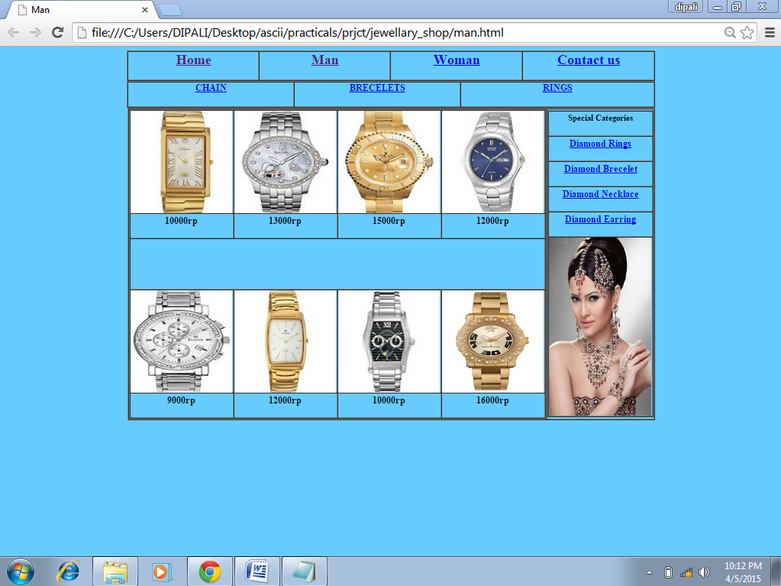

**(**woman page**)**

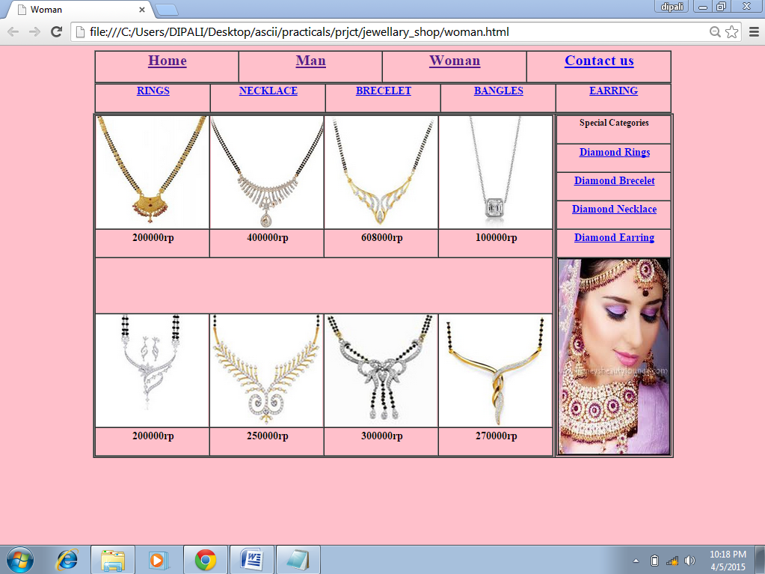

**(**diamonring**)**

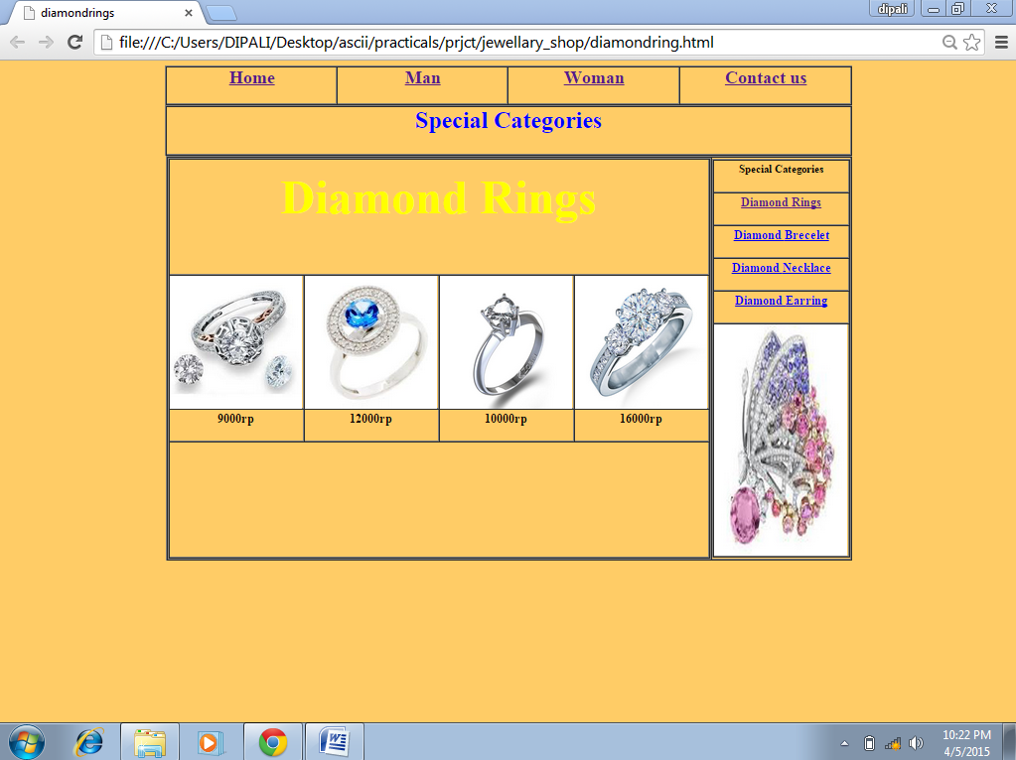

**(contact us page)**

